INNER SOUTH CANBERRA  COMMUNITY COUNCIL  PUBLIC FORUM Thursday 28 April 2016  7.00 pm Wesley Uniting Church Hall  20-22 National Circuit, Forrest  This is a public meeting, parking is available on-site  Please show this to others who may have an interest | 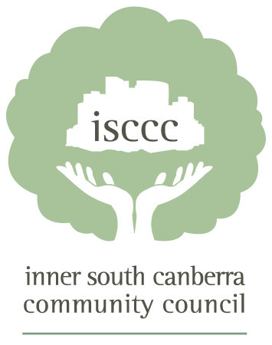

PROPOSED MANUKA OVAL DEVELOPMENT
HOW WILL IT AFFECT YOU?

The ACT Government has received an unsolicited bid from Greater Western Sydney Giants to re-develop the Manuka Oval and surrounds.

You will be affected if you:
- live or work in Manuka, Kingston, Barton, Griffith or Forrest
- shop, eat or relax at Manuka, Kingston or the Foreshore
- use Manuka Pool or Telopea Park
- have children who attend Telopea Park School or MOCCA
- belong to the Canberra Services Club
- attend the Manuka Arts Precinct
- travel to and from work via Canberra Avenue or Wentworth Avenue.

Speakers:
Gary Rake, Deputy Director General and Chief Operating Officer, Environment and Planning Directorate will explain the process for unsolicited bids and answer your questions. Issues covered may include:
- Heritage and architectural consistency with the area
- Traffic/parking
- Open Space and treed landscape
- Impact on retailers at Manuka, Kingston and Kingston Foreshore

Tony Harris, former NSW Auditor-General, has extensive direct experience in government with unsolicited bid processes and projects.

This meeting will inform ISCCC’s decision on how to respond to emerging public concern about this proposal.

“Public engagement is not optional in a democracy.” Professor Larry Beasley speaking at “Making Canberra’s Heart Sing Events” hosted by the ACT government.

For further information please visit www.isccc.org.au
The ISCCC is the peak body for residents groups in the Inner South.
Hosted jointly with Kingston and Barton Residents Group(KBRG) and Griffith Narrabundah Community Association(GNCA)

