INNER SOUTH CANBERRA  COMMUNITY COUNCIL  PUBLIC FORUM 5 March 2015  7.00 pm Eastlake Football Club  Mr Fluffy  Residential Asbestos in the ACT | 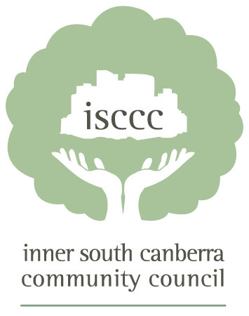
www.isccc.org.au

Agenda

Introduction: Gary Kent, Chair ISCCC

Update on Mr Fluffy Buyback Scheme: Andrew Kefford, Head of the Asbestos Response Taskforce (ART).

Support to Homeowners: Emily Springett, Manager Personal Support Team, ART

Pilot Demolition Programme: Andrew Kefford

Proposed Mr Fluffy Territory Plan Variation: Jim Corrigan, Executive Director of Planning Delivery, Environment and Planning Directorate

There will be Q&A after each topic.

For further information contact Gary on 0419 854 211

